# PROBLEM 1: EDGE DETECTION

## Three images as shown in Fig. 1 are given in this problem. For each given image, you are required to generate several edge maps using the following methods. [Please mark the edge points with intensity value 1 and background points with intensity value 0.] For each method, please apply different parameters and provide some discussions on how they would affect the resultant edge maps. From the observations of your results, list pros and cons of each method, respectively.

## 

## (a) Sobel edge detection

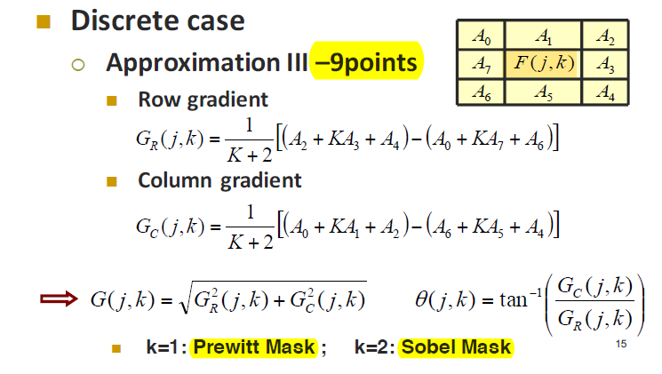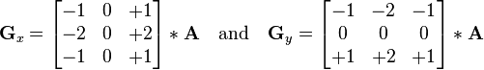

展開row gradient and column gradient之後,可得到gradient magnitude如下的matlab code:

%%%%%%%%%%%%%%%%%%%%%%%%%%%%%%%%%%%%%%%%%%

%sobel.m

%%%%%%%%%%%%%%%%%%%%%%%%%%%%%%%%%%%%%%%%%%

for i=1:size(I,1)-2

for j=1:size(I,2)-2

%Gx : Sobel mask for x-direction: Column gradient

**dx**=( (I(i+2,j) + 2*I(i+2,j+1) + I(i+2,j+2) ) - ( I(i,j) + 2*I(i,j+1)+ I(i,j+2) ) );

%Gy : Sobel mask for y-direction: row gradient

**dy**=( ( I(i,j+2) + 2*I(i+1,j+2) + I(i+2,j+2) )- ( I(i,j) + 2*I(i+1,j) + I(i+2,j) ) );

%Orthogonal gradient Magnitude

**G(i,j)=sqrt(dx.^2+dy.^2);**

Gx(i,j)=dx;

Gy(i,j)=dy;

end

End

## Threshold selection for sobel edge detection.

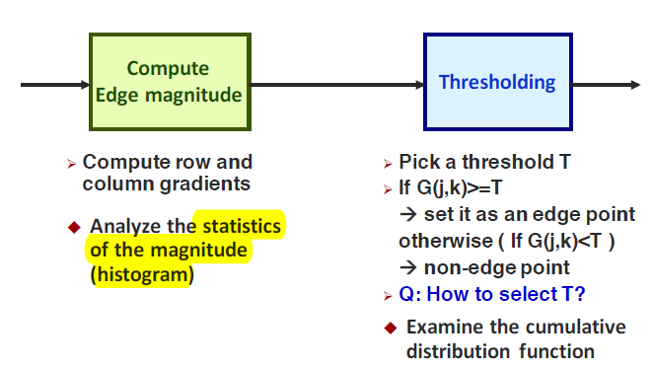

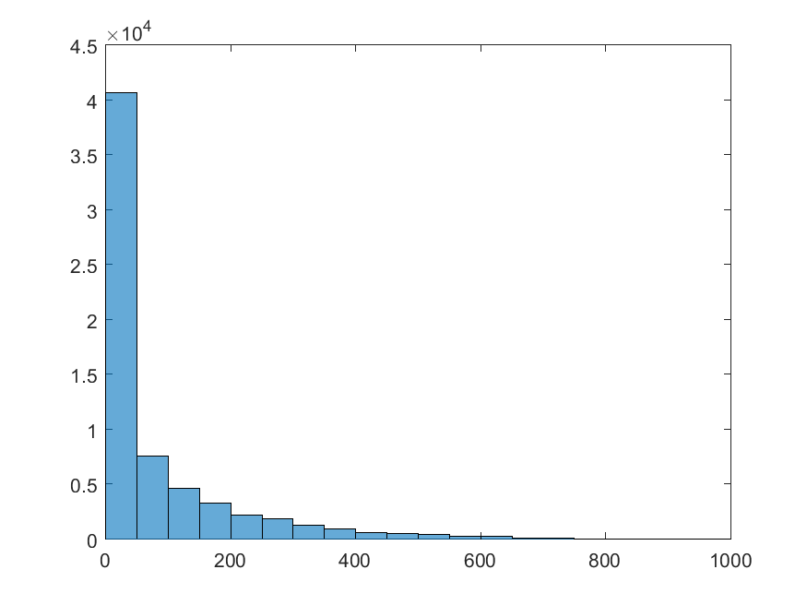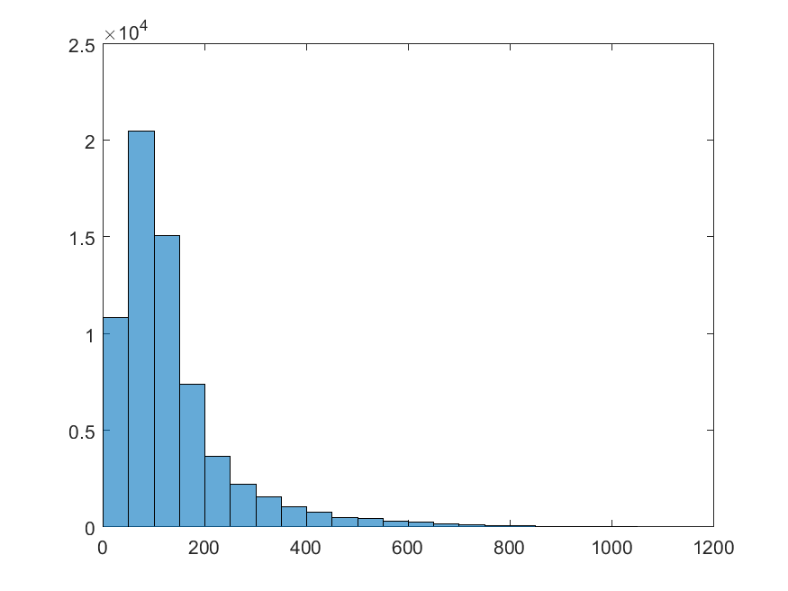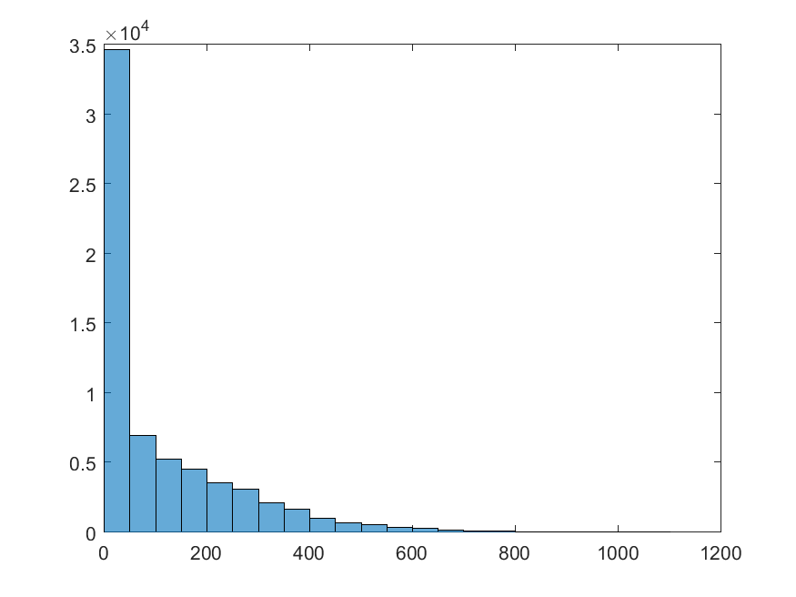

上面三個圖分別為sample1, sample2, sample3 的gradient magnitude histogram. magnitude主要分布在 100以下, 而200以上變少,因此挑**threshold分別為50, 100, 250,** 並觀察edge detection 效果.

**Sample1.raw Threshold 50**

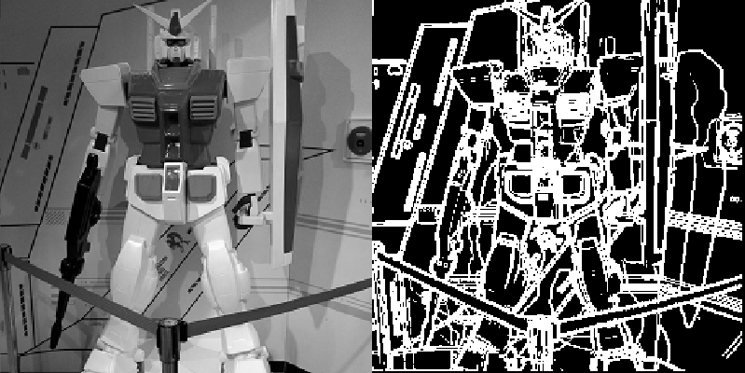

**Sample1.raw Threshold 100**

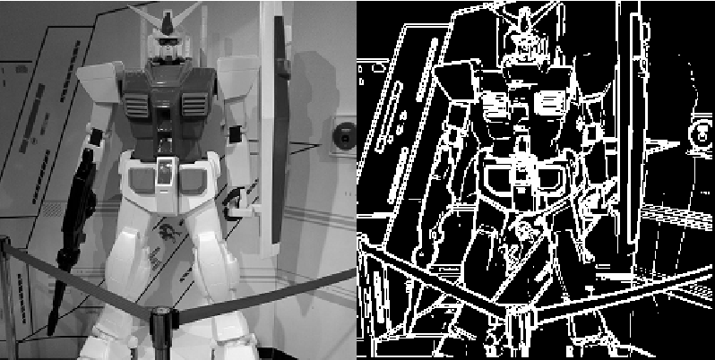

**Sample1.raw Threshold 250**

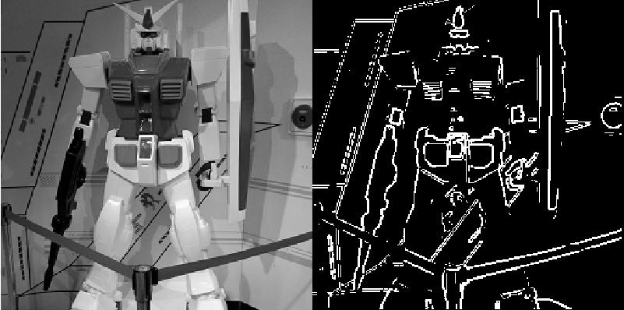

**Sample2.raw Threshold 50**

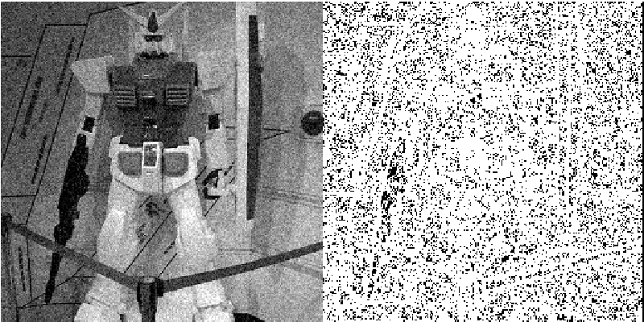

**Sample2.raw Threshold 100**

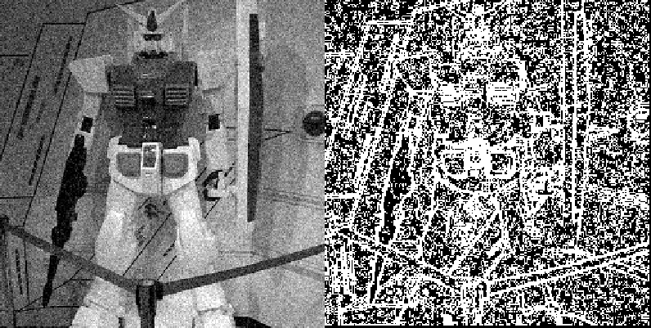

**Sample2.raw Threshold 250**

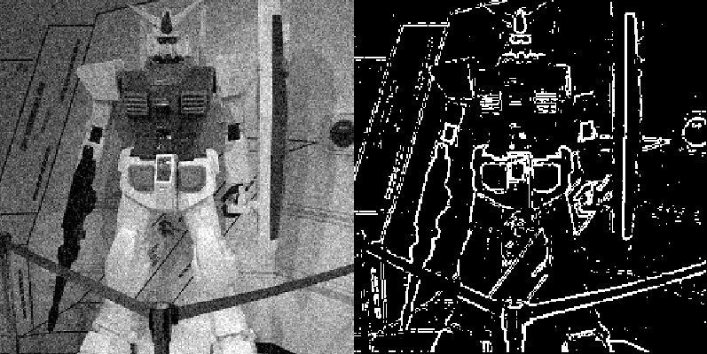

提高threshold可以減少noise造成的error edge,但是正常的edge也會減少. White noise 會造成很多的強gradient magnitude, 產生許多的false edges

**Sample3.raw Threshold 50**

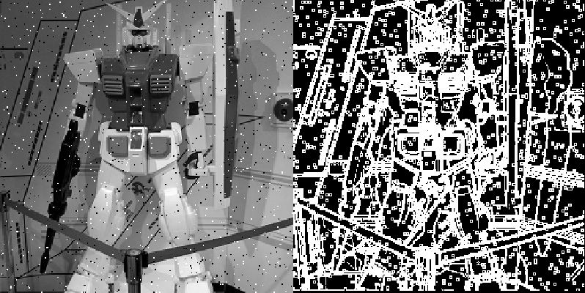

**Sample3.raw Threshold 100**

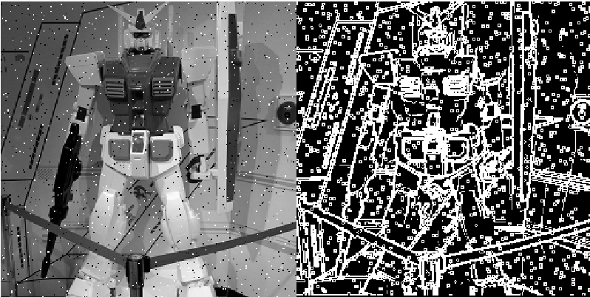

**Sample3.raw Threshold 250**

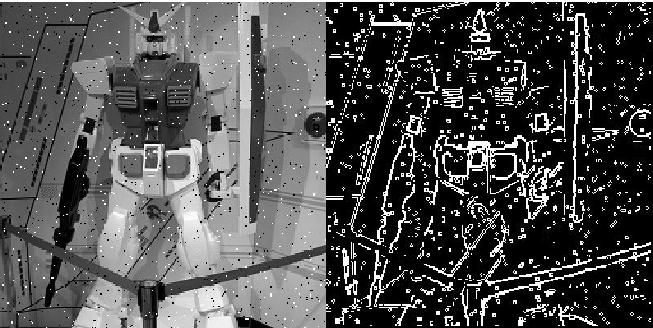

Impulse noise (pepper-and-salt)也會造成很多的強gradient magnitude, 產生許多的false edges,但程度上比white noise少. 可以使用median filter先過濾impulse noise.

## Threshold 50

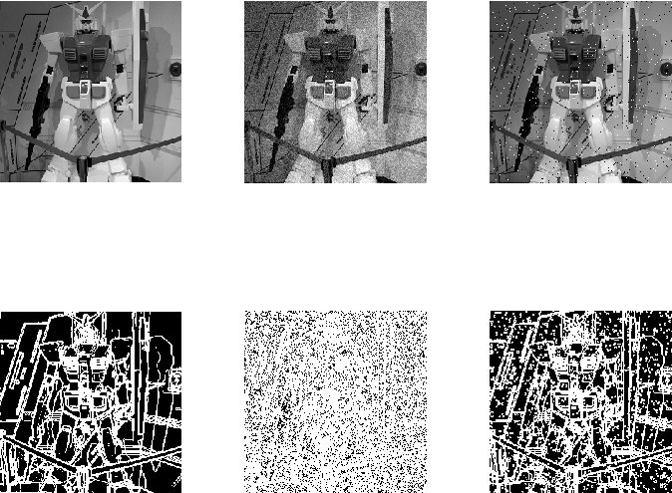

## Threshold 100

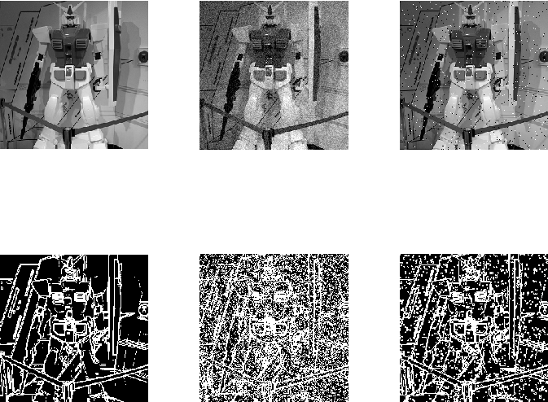

## Threshold 250

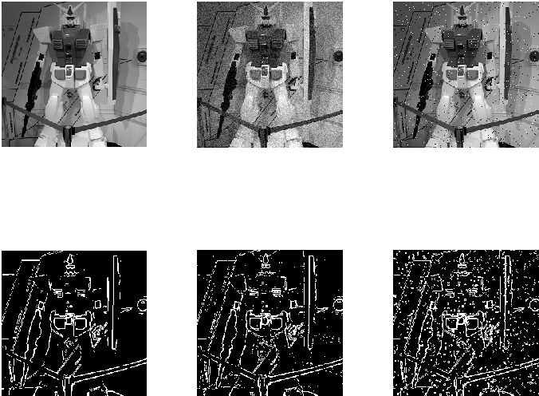

## (b) 2nd order edge detection

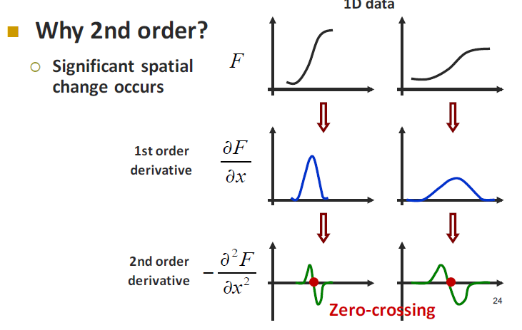

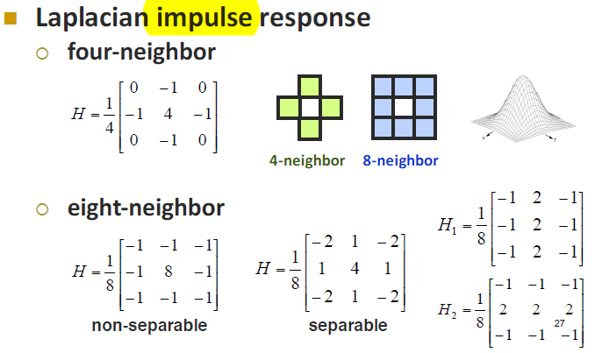

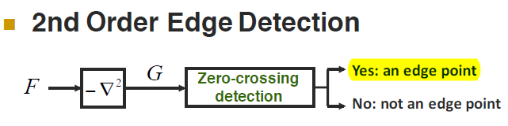

The Laplacian edge filter is used to detect edges.

**Laplacian-ZC-edge-detect-thr-20-4N-8N**: The upper row is from 4-neighbor Laplacian filter and the lower row is from 8-neighbor. 2nd Order Edge Detection is very sensitive to noise. **Sample2.raw** is contaminated with **white noise**, so the noise is everywhere.

The **4-neighbor** Laplacian filter is more sensitive to noise than **8-neighbor** Laplacian filter. Sample3 is contaminated with impulse noise, so the false edges are detected around the pepper-and-salt noise.

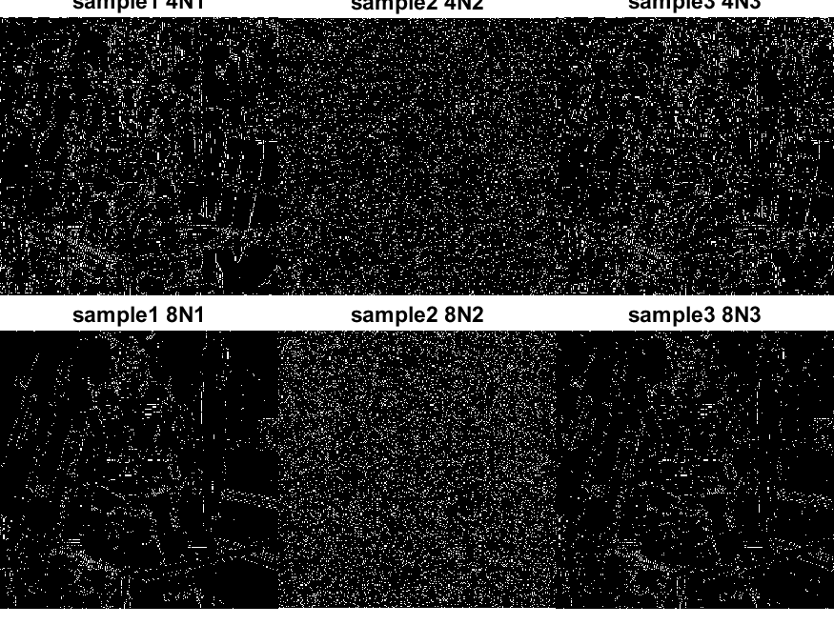

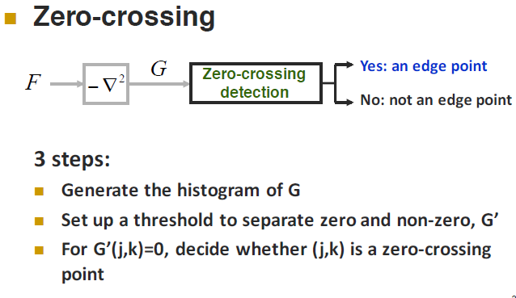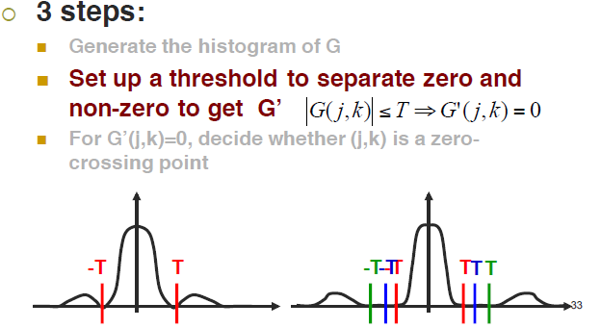

By setup different thresholds for zero-crossing, different 0-1 edge maps are generated.

**Laplacian-ZC-edge-detect-thr-60-4N-8N** :

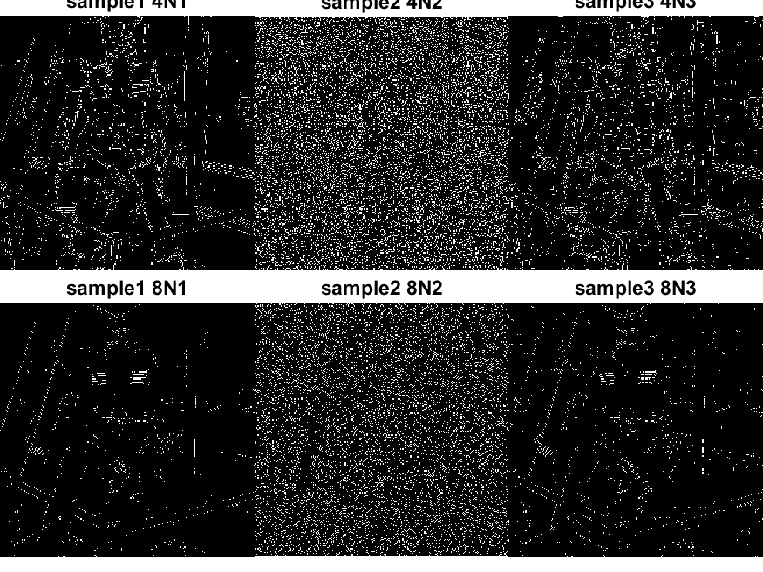

**Laplacian-ZC-edge-detect-thr-100-4N-8N:**

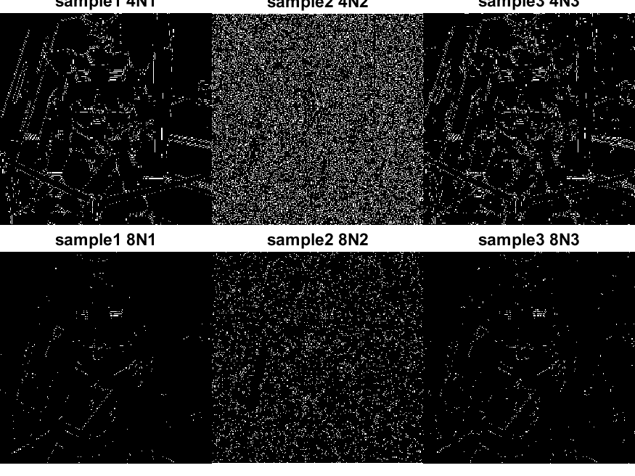

The higher threshold for zero-crossing generates less edges. Though higher threshold has higher immunity to noise, the true edges are also filtered out.

## 

**LOG has higher immunity to noise. The following is the result.**

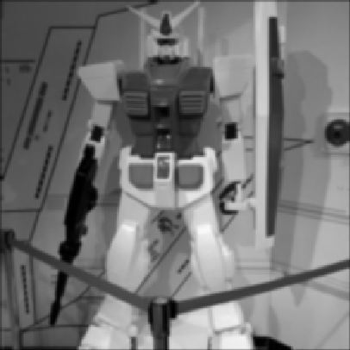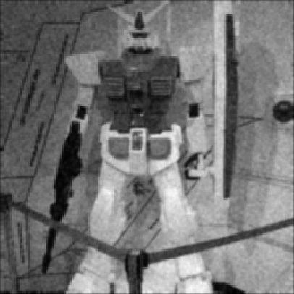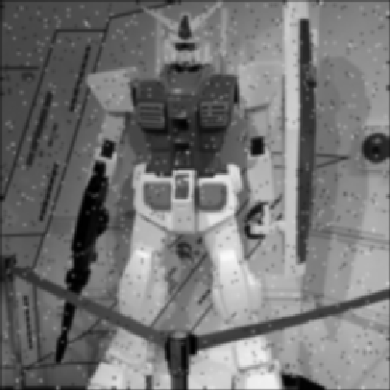

**LOG-ZC-edge-detect-thr-1-4N-8N:**

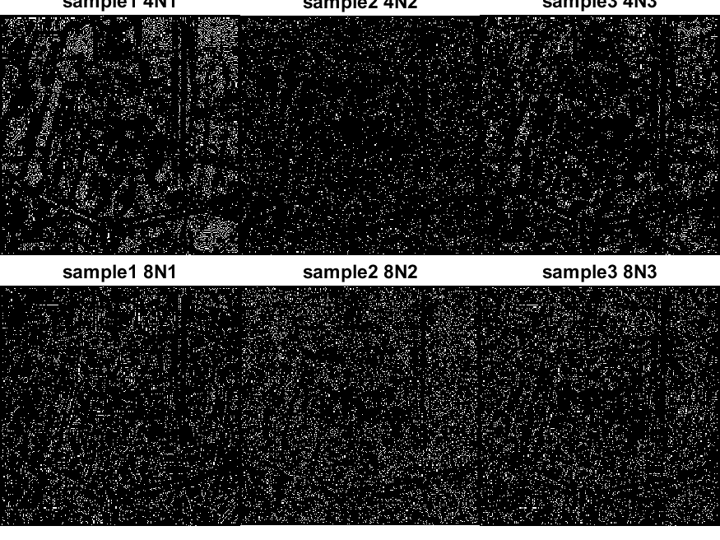

**LOG-ZC-edge-detect-thr-3-4N-8N:**

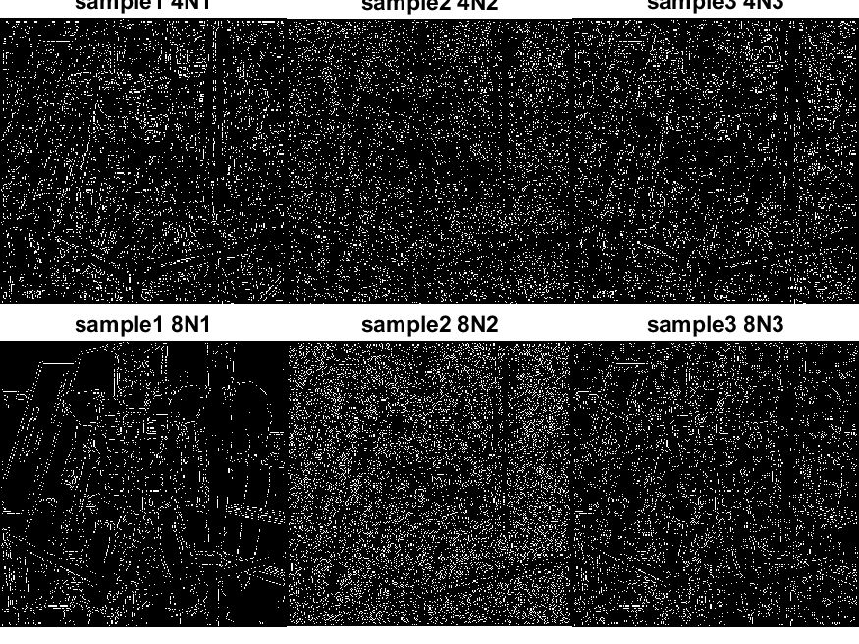

**LOG-ZC-edge-detect-thr-10-4N-8N:**

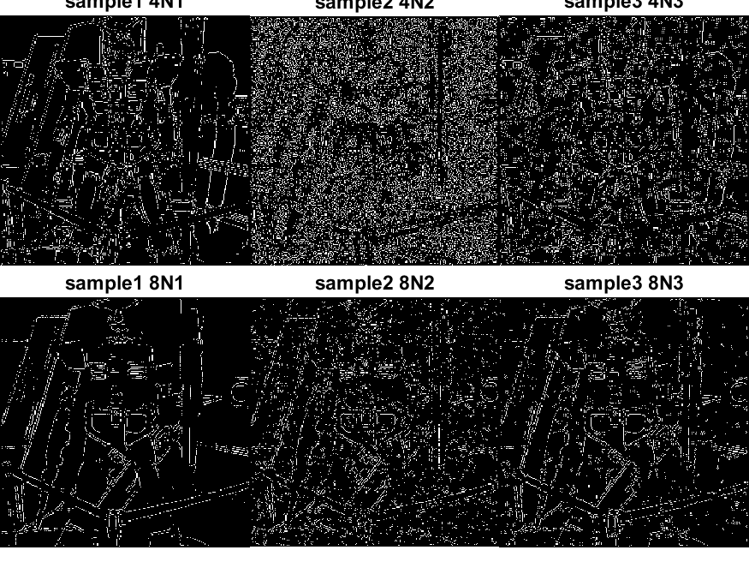

The higher threshold is for zero-crossing, the better edge quality is because the zero-crossing around the noise are filtered.

## (c) Canny edge detection

# 

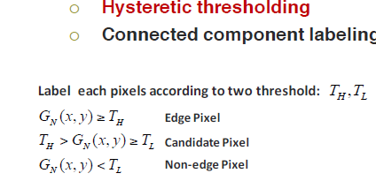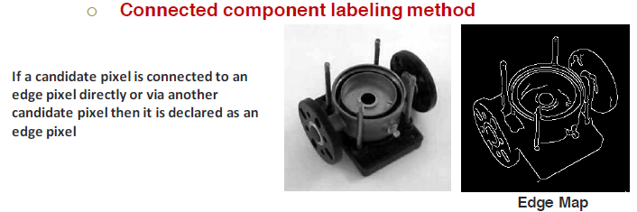

Though I **google** for a canny.m and then I review the code and study the code, **I have not finished it yet**. I just revised the canny.m and the result shows better than sobel and laplacian edge filters. Canny has higher time complexity than sobel and laplacian edge filters.

The sample code, canny.m, uses Derivative of Gaussian filter for the step 1, noise reduction, and step 2, gradient magnitude and orientation, but I don’t understand why this filter works for both steps.

Besides It’s hard to decide hysteretic thresholds unless couple thresholds are tried.

**The following results are from the sample code, canny.m with some revisions by me.**

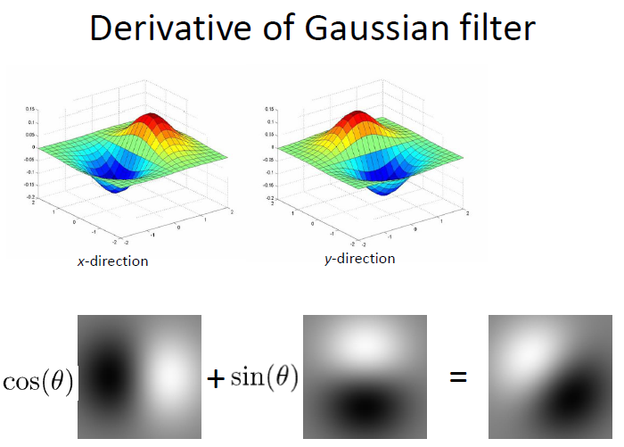

**canny-edge-detect-suite-1.png**

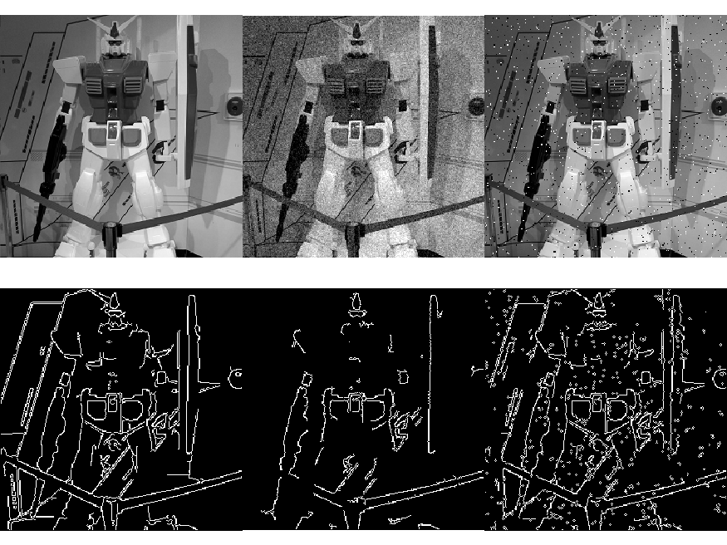

**canny-edge-detect-suite-2.png**

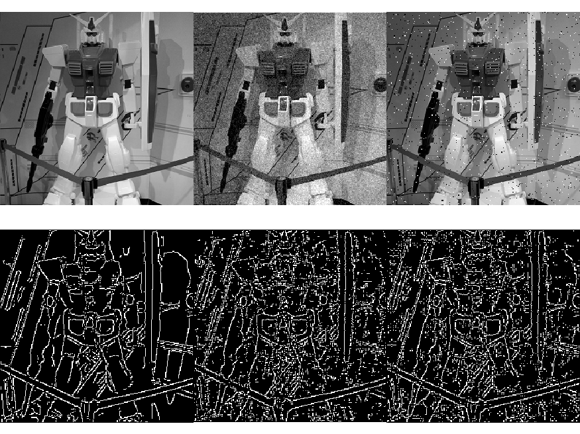

**canny-edge-detect-suite-3.png**

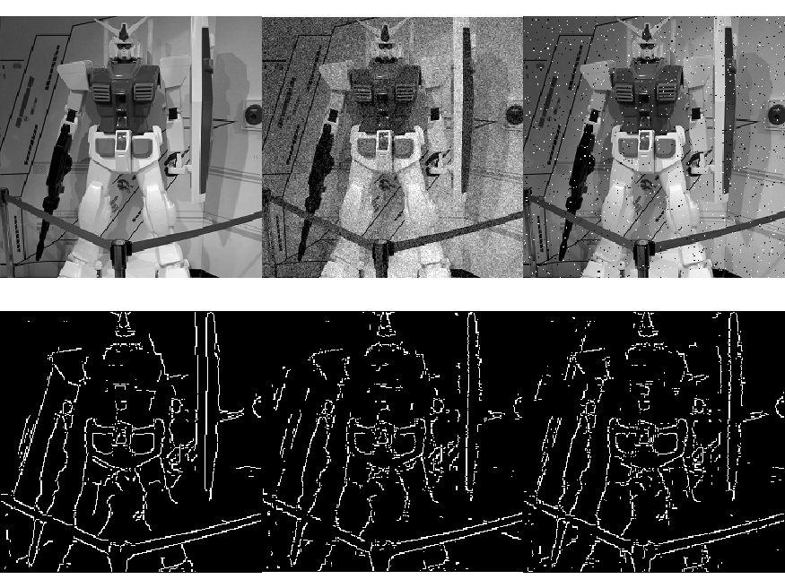

# PROBLEM 2: GEOMETRICAL MODIFICATION

## (a) Please stitch these four images into one complete image and paint the residual regions in black. Denote the result as R.

We have no advanced image process toolbox and any computer vision toolbox, so we can’t use any keypoint descriptors to register images. An alternative algorithm searches the minimum mean square error among all possible overlapped regions between the two images. The time complexity is larger than O(M*N) for M*N images:

1. **Stitching**(image A. image B)
2. Given 2 images A,B
3. One image A is centered at a large canvas C with background “0”
4. The other image B acts as a moving window inside the canvas.
5. Move image B over the whole canvas C pixel by pixel
   1. Find the overlapped region O between the A and B, such that Oa is the intersection region in A,Ob is the intersection region in B.
   2. If O is larger than 10x10, the O may be a possible stitching region between A and B
      1. Computing the mean square error, MSE, between Oa and Ob
      2. If MSE is minimum, save it
   3. Goto 4
6. If the minimum MSE does exist, stitching A and B to image r by the overlapped region O.

In order to save time, manually select the start position of moving window for sample4, sample5, sample6 and sample7.

Stitch two images at a time and record the corner positions of the two stitching images. The stitching sequence is

1. Sample 4 + Sample5

2. Sample 4 + Sample7

3. Sample 5 + Sample6

The sample4 is a pivot image to stitching 4 images together. The following is the stitching images:

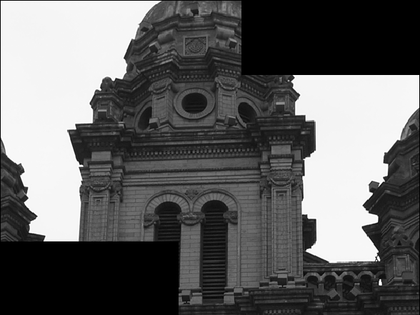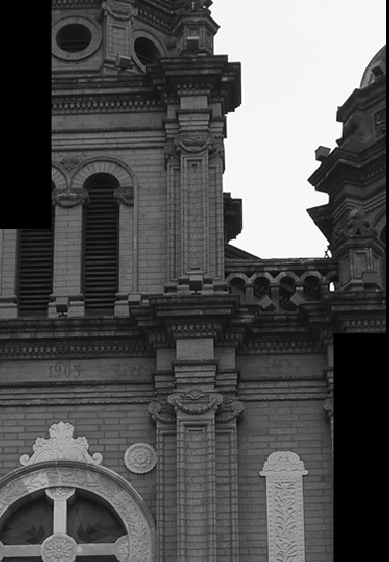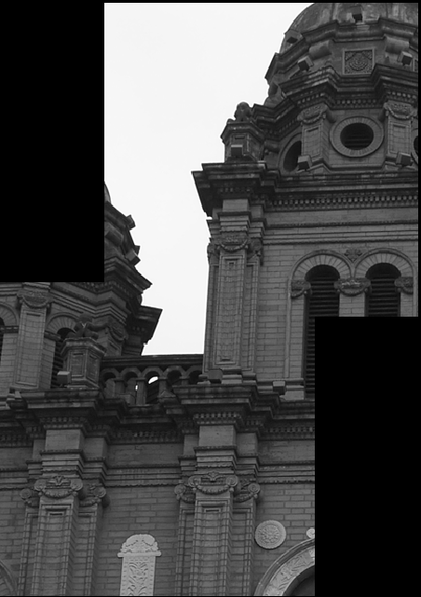

sample4 and sample5 sample5.raw and sample6.raw sample4 and sample7

A canvas, (3*row) * (3*col), is created with the origin at the left top corner. The corners of each stitching operation are known in the canvas, so the 4 corners of the 4 stitching images are known. Draw the 4 images by the 4 known corners to the canvas. The Target R is obtained!

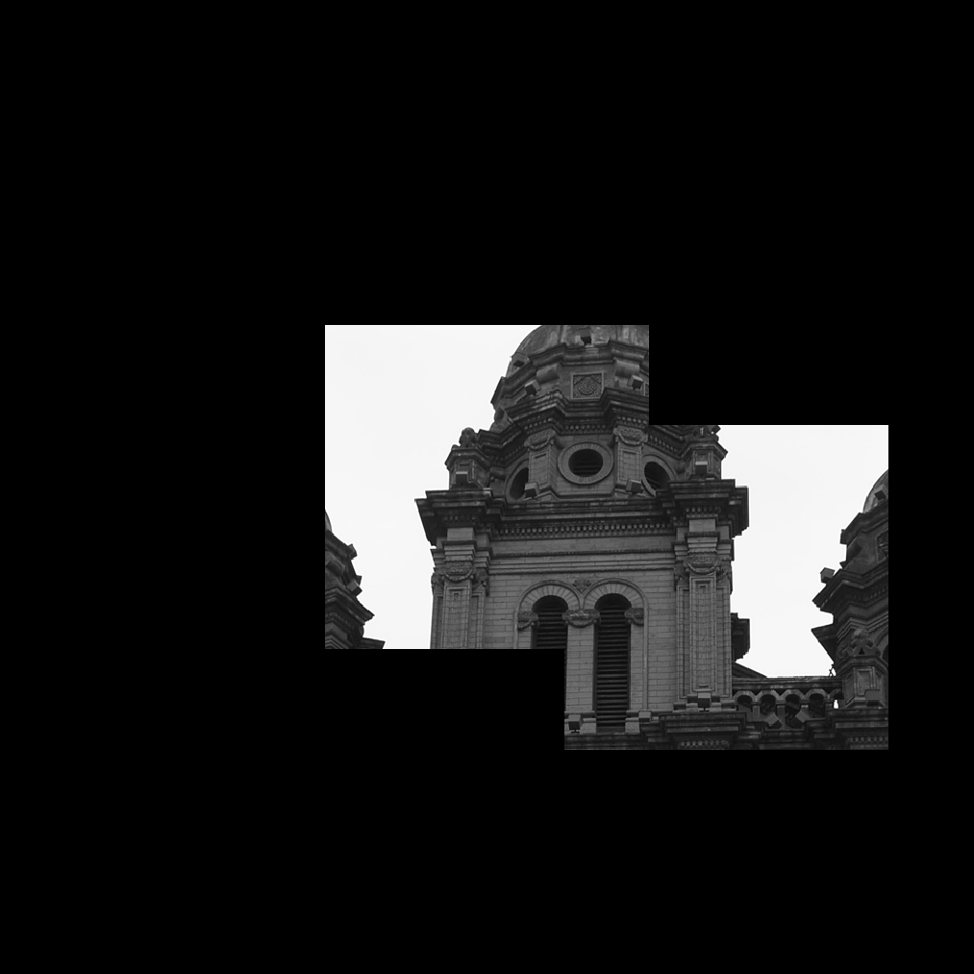 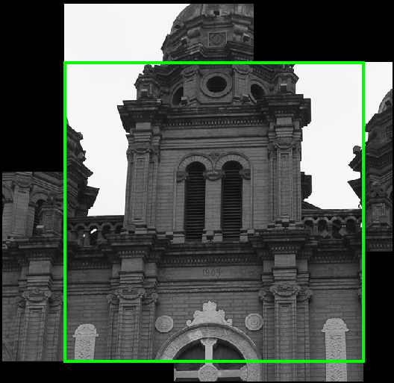

A canvas is created as a stitching container. **The result stitching image R**.

## (b) Crop the largest square image of image R and denote it as S. (Hint: the size of S is 512x512.)

The 4 corners of the 4 images in the canvas are known, so the bounding box is selected manually by the 4 corners.

corner_S1 =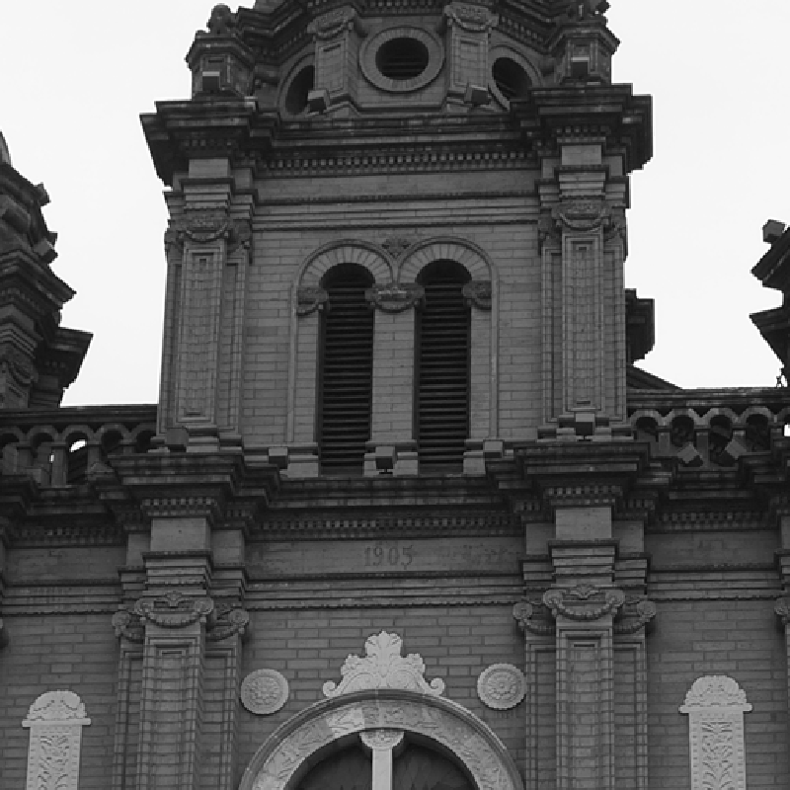

325 325

corner_S2 =

425 564

corner_S3 =

648 513

corner_S4 =

613 218

%%%%%%%%%%%%%%%%%%%%%%%%%%%%%%%%%%%%%

%S1: sample4, S2: sample5, S3:sample6, S4:sample7

%x1 of corner_S1(y1, x1) -> x2 of corner_S3(y2, x2)

%y1 of corner_S2(y1, x1) -> y2 of corner_S4(y2, x2)

hold on;

% draw rectangle [x y w h]

x=corner_S1(2);

y=corner_S2(1);

w = (corner_S3(2) + col -1) - corner_S1(2) + 1;

h = (corner_S4(1) + row -1) - corner_S2(1) + 1;

rectangle('Position', [x y w h]);

%%%%%%%%%%%%%%%%%%%%%%%%%%%%%%%%

**>> [x y w h]**

**ans =**

**325 425 512 512**

**The inscribed rectangle is “w= 512, and h=512” as the expected result!**

**Image S 512x512.**

## 

## (c) As illustrated in Fig. 3, segment the image S into three parts with predefined size and design three warping functions to convert the image to a gourd-shaped image. Output the result as G.

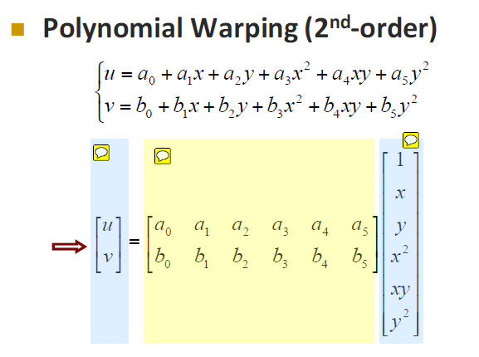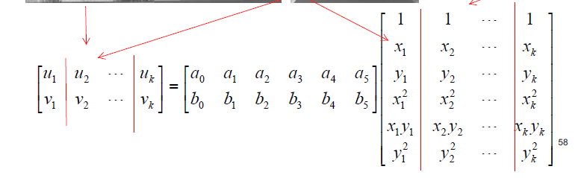

Forward mapping: There are many pixels missed in warped image. Instead, reverse mapping can make sure every pixel in a warped image won’t miss any pixel.

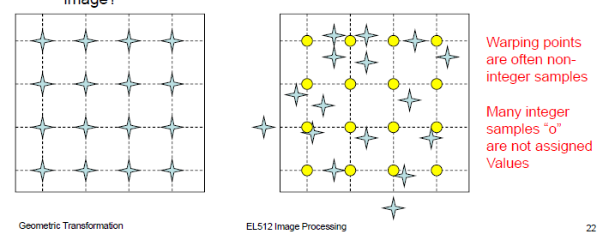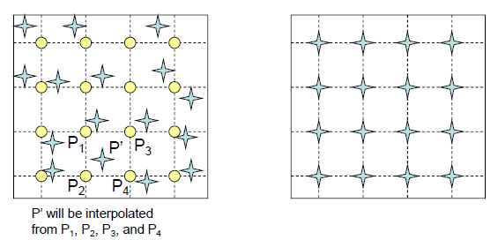

1. Gourd head: **subsampling** from 512x64 to 32x64. 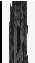
2. Middle Gourd : It’s a circle.
   1. Find the points inside the circle
   2. Find the paired pixels inside the original image by reverse transform.
   3. A circle equation : **x^2 + y^2 = r^2**, so any point (x0,y0) that x0^2 + y0^2 <= r^2 is inside the circle.
   4. An ellipse equation : **x^2/a^2 + y^2/b^2= 1**, so any point (x0,y0) that x0^2/a^2 + y0^2/b^2 <= 1 is inside the ellipse.

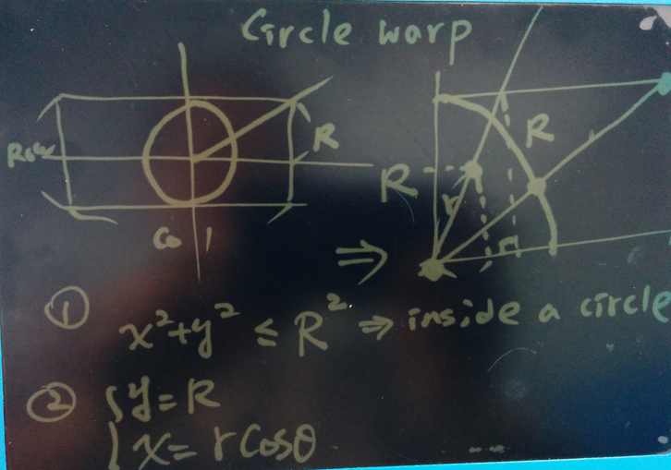 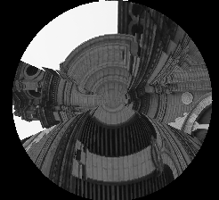

There are something wrong in my code, so it’s not a good warping.

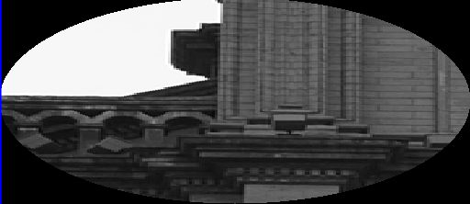

I use 8 or 9 control points pair by matlab’s fixpoints and moving points transform tool, but it does not work well.

So the final warped image is not well, eight.

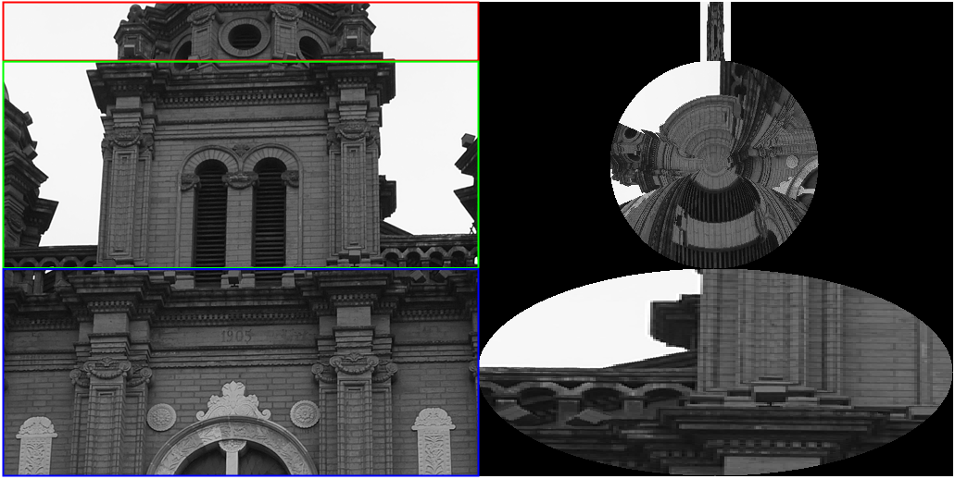

# PROBLEM 3: TEXTURE ANALYSIS Fig. 4 demonstrates a gray-level image which is composed of several animals with different texture patterns.

## Motivation : there are 3 different animal textures in the image, so Laws’ method is used to retrieve the texture vector of each pixel. Then unsupervised K-means algorithm is used to get 4 clusters including 3 animal textures and 1 background texture. The 3 animal texture sizes are different, so 3 different window sizes are tried to get a better texture analysis for different animals. 3x3 and 5x5 Filters are used to analyze the texture, too. Different energy method retrieve different feature vectors, so 4 methods are used to evaluate the classification.

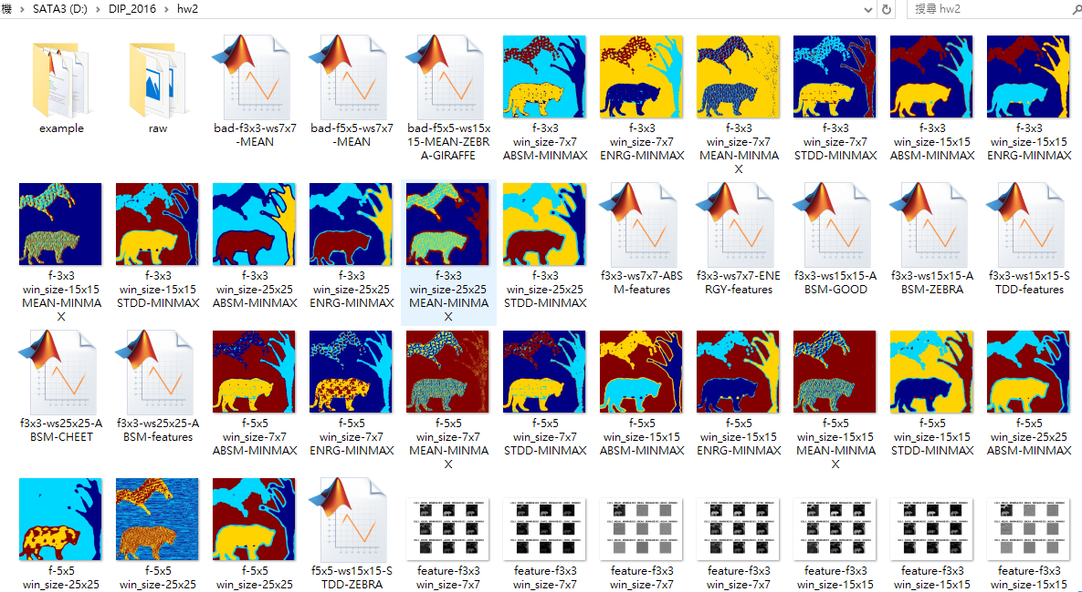

## (a) Perform Law’s method on the given image to obtain the feature vector of each pixel.

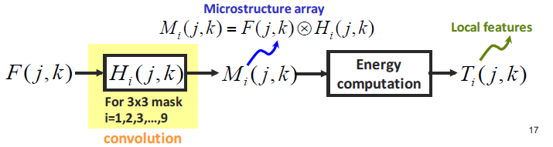

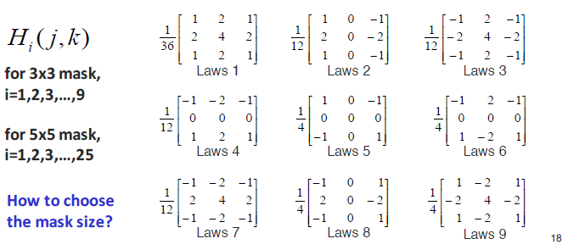

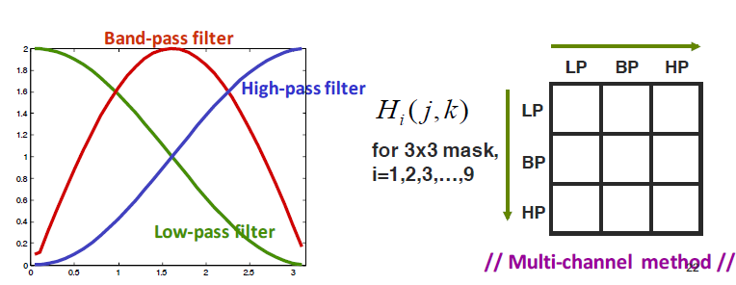

5x5 Laws mask

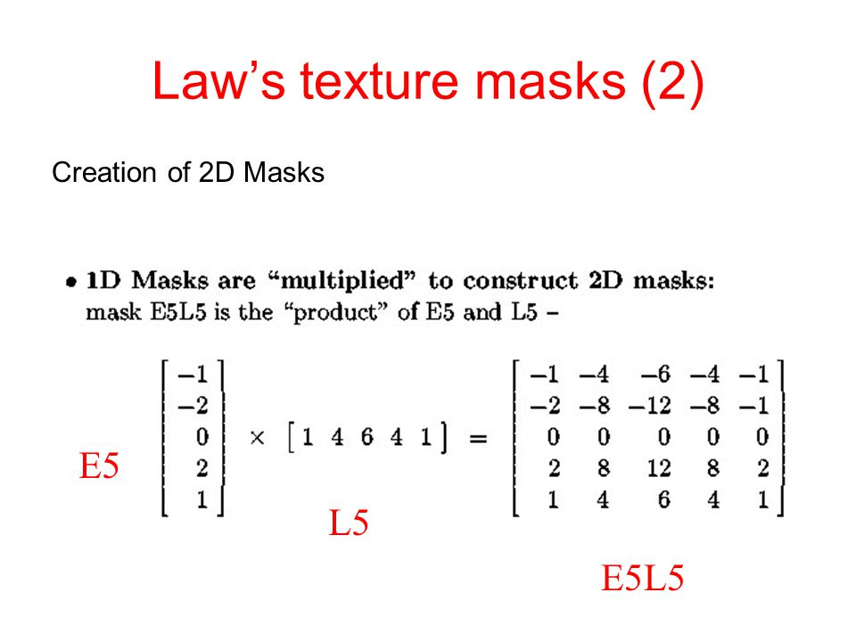

L5 = [ +1 +4 6 +4 +1 ] (Level)  
 E5 = [ -1 -2 0 +2 +1 ] (Edge)  
 S5 = [ -1 0 2 0 -1 ] (Spot)  
 W5 = [ -1 +2 0 -2 +1 ] (Wave)  
 R5 = [ +1 -4 6 -4 +1 ] (Ripple)

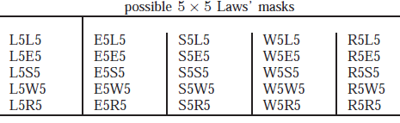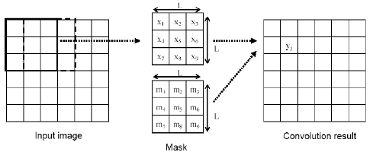

**There are two Laws filters, 3x3 mask filters and 5x5 mask filters, used to verify the results.**

**3x3-mask-filter has 9 mask/kernel and 5x5-mask-filter has 25 mask/kernel.**

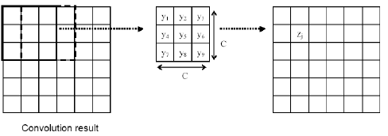

**Energy Computation** : There are **four statistic types,** **energy, absolute mean, standard deviation and simple mean**, to calculate the feature vectors.

**Window size**: Giraffe, Cheetah or Zebra has its own texture whose size is different to the other texture. A window covers a few repetitive textures is required , so **3 different window size**,7x7, 25x25, 15x15, are used.

%%%%%%%%%%%%%%%%%%%%%%%%%%%%%%%%%%%%%%%%%%%

**window_sizes = [7; 25 ; 15];** %usually 13x13 or 15x15

**%3x3 filters = 9 filters**

filter_types_3x3 = ['L3L3'; 'L3E3'; 'L3S3';...

'E3L3'; 'E3E3'; 'E3S3';...

'S3L3'; 'S3E3'; 'S3S3'];

**%5x5 filters = 25 filters**

filter_types_5x5 = ['L5L5'; 'L5E5'; 'L5S5'; 'L5W5'; 'L5R5';...

'E5L5'; 'E5E5'; 'E5S5'; 'E5W5'; 'E5R5';...

'W5L5'; 'W5E5'; 'W5S5'; 'W5W5'; 'W5R5';...

'S5L5'; 'S5E5'; 'S5S5'; 'S5W5'; 'S5R5';...

'R5L5'; 'R5E5'; 'R5S5'; 'R5W5'; 'R5R5'];

%column-wise by ";" separator in [], computing features by

**statistic_types = ['ENRG' ; 'ABSM'; 'STDD'; 'MEAN' ];**

normalizing_types = ['MINMAX'; 'FORCON'];

%%%%%%%%%%%%%%%%%%%%%%%%%%%%%%%

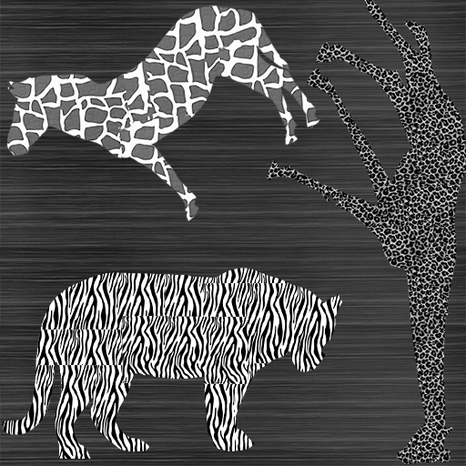

Window size consideration to computer texture energy:

1. The **giraffe** contains a very small texture size, so I think **7x7 window size will have a better classification for a giraffe**. 7x7 window is only used to distinguish a giraffe from the others..
2. **The cheetah** has the biggest texture size, so **window size 25x25** is used to have a better classification. 25x25 window is only used to distinguish a cheetah from the others.
3. **The zebra** has a mid-size texture, so **15x15 window size is used to** distinguish a zebra from the other.
4. If we want to classify 3 animals simultaneously, 15x15 window size is the best.

A feature vector:

Convolving the image with a filter generates a filtered image, so 3x3 filters generate 9 filtered images and 5x5 filters generate 25 images. Concatenate the 9 or 25 images to form a 3D matrix whose depth is a feature vector of a pixel.

%%%%%%%%%%%%%%%%%%%%%%%%%%%%%%%%%%%%%%%%%%

for i = 1 : size(filter_types_5x5,1),

temporary = Laws_mask(imageG, filter_types_5x5(i,:), window_size, statistic_type, normalizing_type);

% The result matrix, D, concatnates the Laws_mask result matrixs, M * N, to a 3D matrix.

% D is M * N * 9, if filter is 3x3

if(i == 1),

D = **cat(3,temporary); %merge 2D Mi to 3D matrix along 3rd dimension, 3x3 or 5x5. Each M is indexed by the 3rd dimension**

else

D = **cat(3,D,temporary);**

end

figure(2+ 100*ws); subplot(5,5,i); imshow(temporary); title([filter_types_5x5(i,:) ' , ' statistic_type ' , ' normalizing_type]);

end

%%%%%%%%%%%%%%%%%%%%%%%%%%%%%%%%%%%%%%%%%%%%%%%%%%%%%

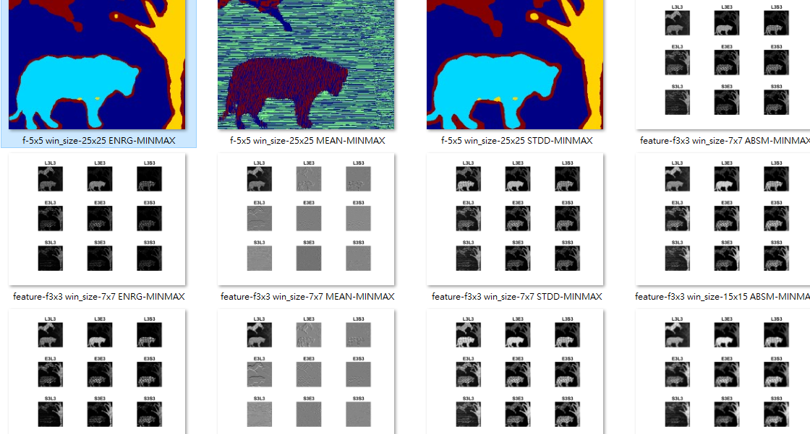

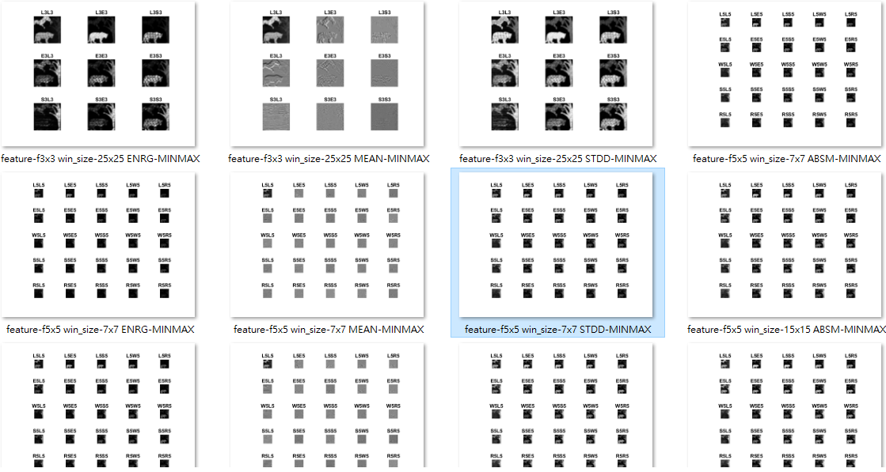

## 

## (b) Use k-means to classify each pixel and label same kind of texture with same intensity. Please specify the intensity levels you adopt and output the result as L.

The 3 animals are assigned by wrong textures. Manually crop the maximum inscribed rectangle inside the animal contour. The inscribed rectangle contains the homogenous texture.

1. The texture inside a zebra belongs to a giraffe. Name It Tg.

2. The texture inside a cheetah belongs to a zebra. Name it Tz.

3. The texture inside a giraffe belongs to a cheetah. Name it Tc.

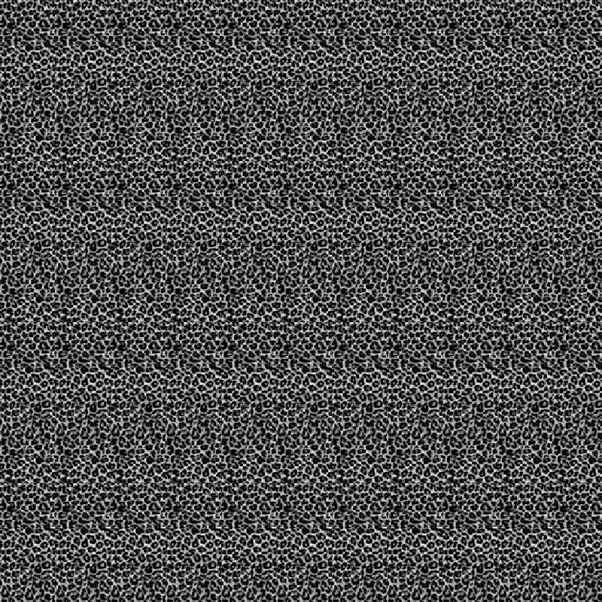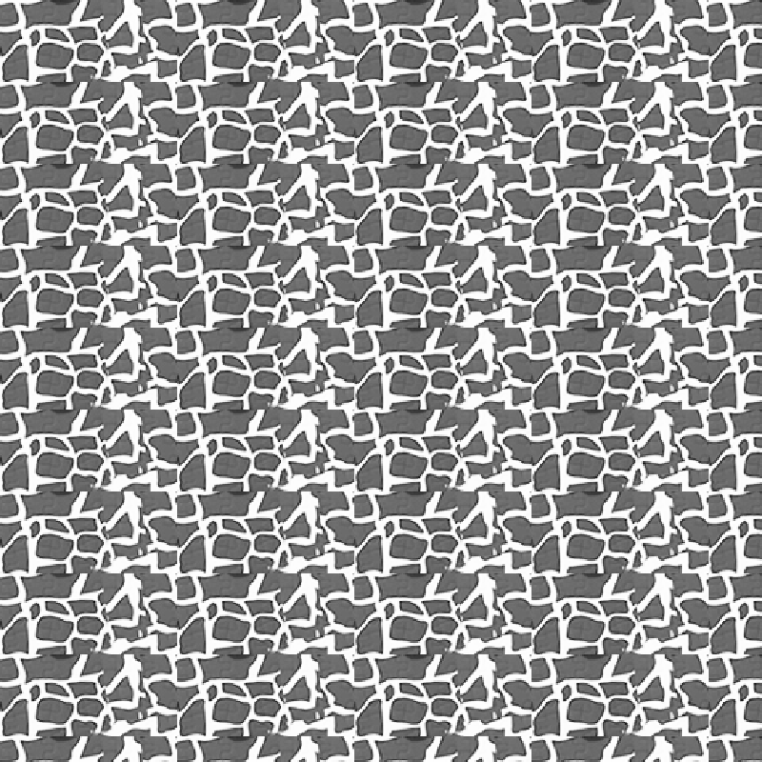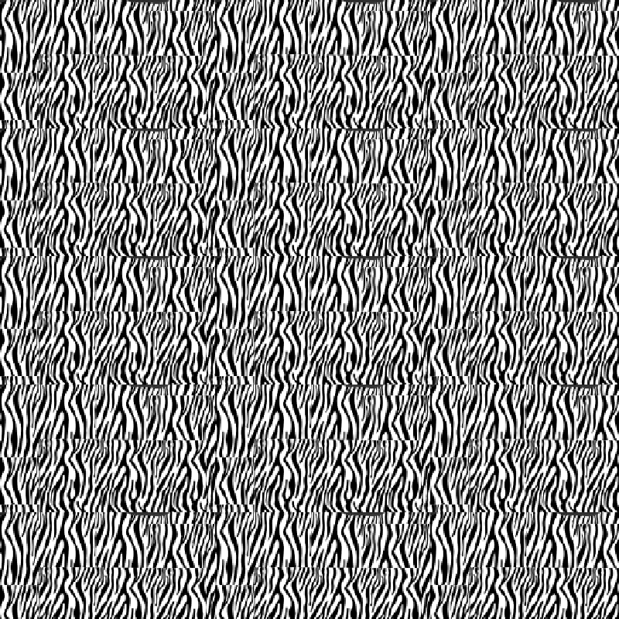

Repeat the inscribed rectangle ,Tg, Tz and Tc to a full individual image whose dimension is the same as the sample8.raw.

1. Repeat Tg to generate a full image as **TG**.
2. Repeat Tz to generate a full image as **TZ**.
3. Repeat Tc to generate a full image as **TC**.

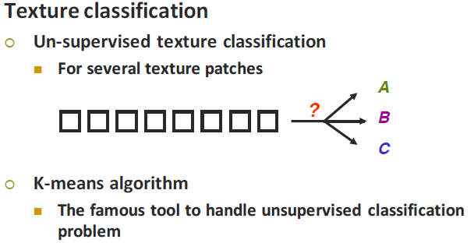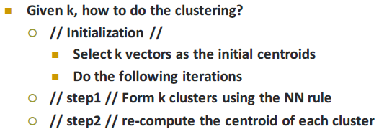

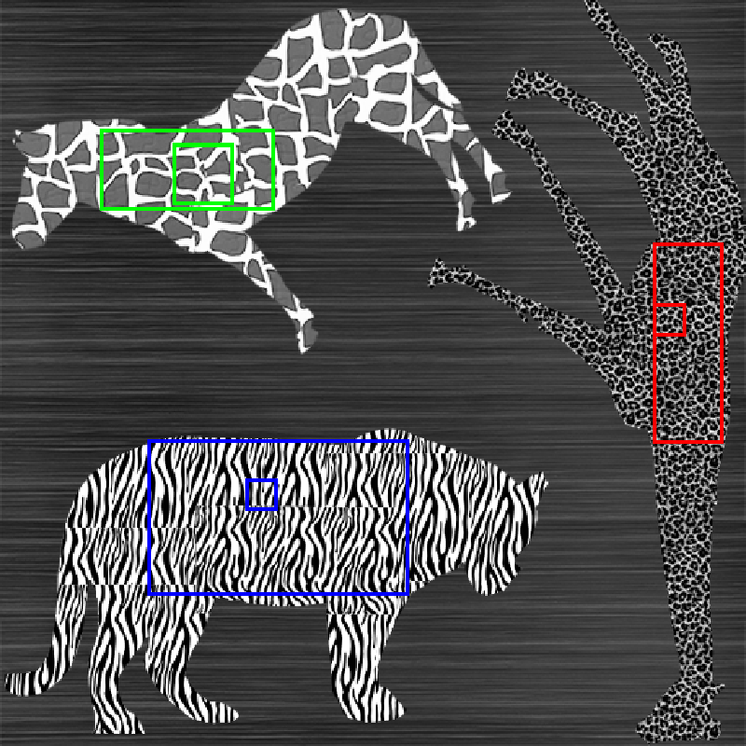

**K(=4 clusters)** is chosen to **unsupervised K-means algorithm**, because there are 4 kinds of textures, zebra, cheetah, giraffe and background pre-defined by human eyes. The initial K centers are computed by assigning the random class number (from 1 to k) to each sample vector. The initial 4 centers are equivalent to the class numbers which are randomly assigned to zebra, cheetah, giraffe and background, so the final class numbers are also randomly assigned to animals.

Furthermore, 4 class/cluster numbers should be fixed after k-means algorithm for further processing. Now set Zebra to class #3, giraffe to class #2 and Cheetah to class #1. But How?

1. Manually pick a reference rectangle inside the animal. The smallest colored-rectangle inside the animal, **x**, is the reference rectangle, **rr**.
2. The most frequent class number, **m**, inside the smallest rectangle, **rr**, after k-means algorithm is the class number **m**  for the animal **x**.
3. Zero the region whose number is not **m**, so only the animal **x** region, **rx**, is reserved.
4. Assign a fixed number to animal **x** instead of **m** in the region **rx:** set Zebra to class #3, giraffe to class #2 and Cheetah to class #1
5. Crop the same region, **rx**, in the full homogeneous texture image, **TX**, prepared in advance to obtain a correct texture **Tx** for animal **x**.

Where **TX = TZ** for zebra, **TX=TG** for giraffe and **TX=TC** for cheetah.

1. Animal **x** is in the list of Zebra, Cheetah and Giraffe, so the correct texture mapping for the animal is: **Tz** for zebra, **Tc** for cheetah and **Tg** for giraffe.
2. Union of the **Tz**, **Tc** and **Tg** are the final texture map for 3 animals.

The output files by different parameters:

'f-3x3 win_size-15x15 ABSM-MINMAX.png' 'f-5x5 win_size-15x15 ABSM-MINMAX.png'

'f-3x3 win_size-15x15 ENRG-MINMAX.png' 'f-5x5 win_size-15x15 ENRG-MINMAX.png'

'f-3x3 win_size-15x15 MEAN-MINMAX.png' 'f-5x5 win_size-15x15 MEAN-MINMAX.png'

'f-3x3 win_size-15x15 STDD-MINMAX.png' 'f-5x5 win_size-15x15 STDD-MINMAX.png'

'f-3x3 win_size-25x25 ABSM-MINMAX.png' 'f-5x5 win_size-25x25 ABSM-MINMAX.png'

'f-3x3 win_size-25x25 ENRG-MINMAX.png' 'f-5x5 win_size-25x25 ENRG-MINMAX.png'

'f-3x3 win_size-25x25 MEAN-MINMAX.png' 'f-5x5 win_size-25x25 MEAN-MINMAX.png'

'f-3x3 win_size-25x25 STDD-MINMAX.png' 'f-5x5 win_size-25x25 STDD-MINMAX.png'

'f-3x3 win_size-7x7 ABSM-MINMAX.png' 'f-5x5 win_size-7x7 ABSM-MINMAX.png'

'f-3x3 win_size-7x7 ENRG-MINMAX.png' 'f-5x5 win_size-7x7 ENRG-MINMAX.png'

'f-3x3 win_size-7x7 MEAN-MINMAX.png' 'f-5x5 win_size-7x7 MEAN-MINMAX.png'

'f-3x3 win_size-7x7 STDD-MINMAX.png' 'f-5x5 win_size-7x7 STDD-MINMAX.png'

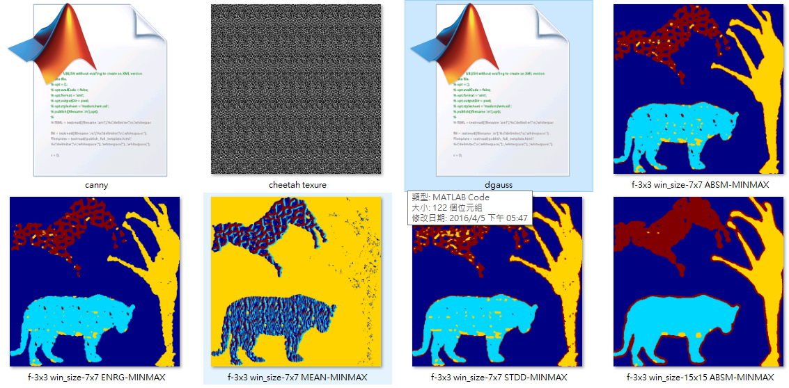

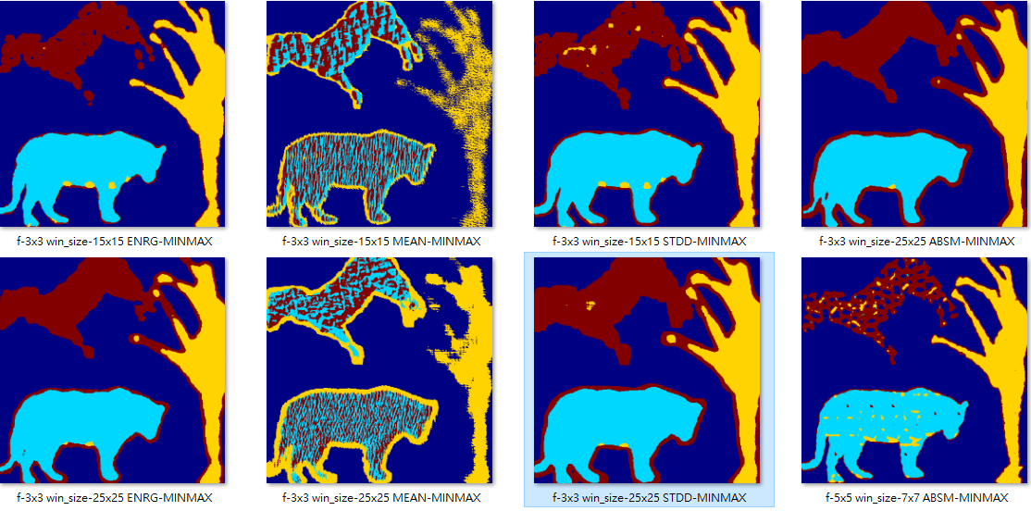

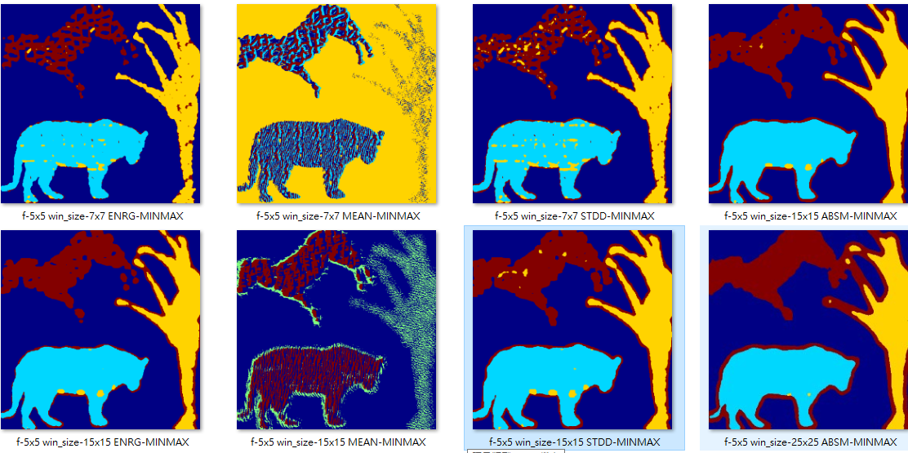

## 

## Giraffe has the smallest texture pattern, so a window size is 7x7 to cover several repetition of a texture.

**f5x5\ win_size-7x7\ ABSM-MINMAX.png** : The best **Giraffe classification.**

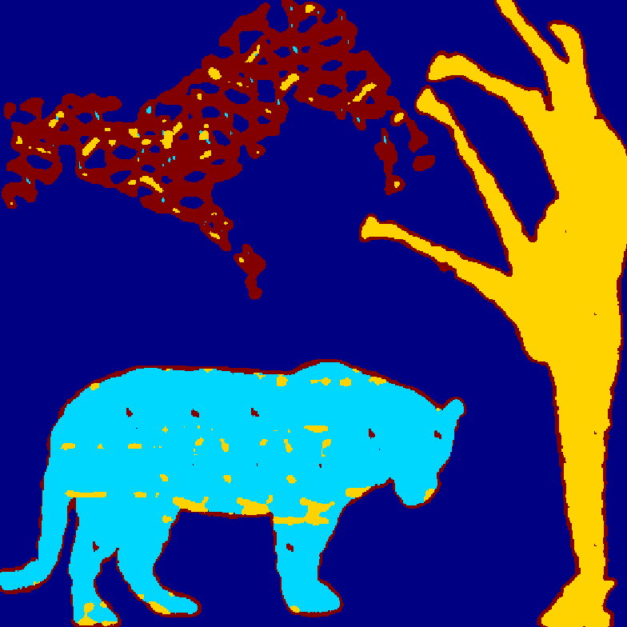

**f3x3\ win_size-7x7\ ABSM-MINMAX.png** : This is **not as good as** the **f5x5\ win_size-7x7\ ABSM-MINMAX.png.**

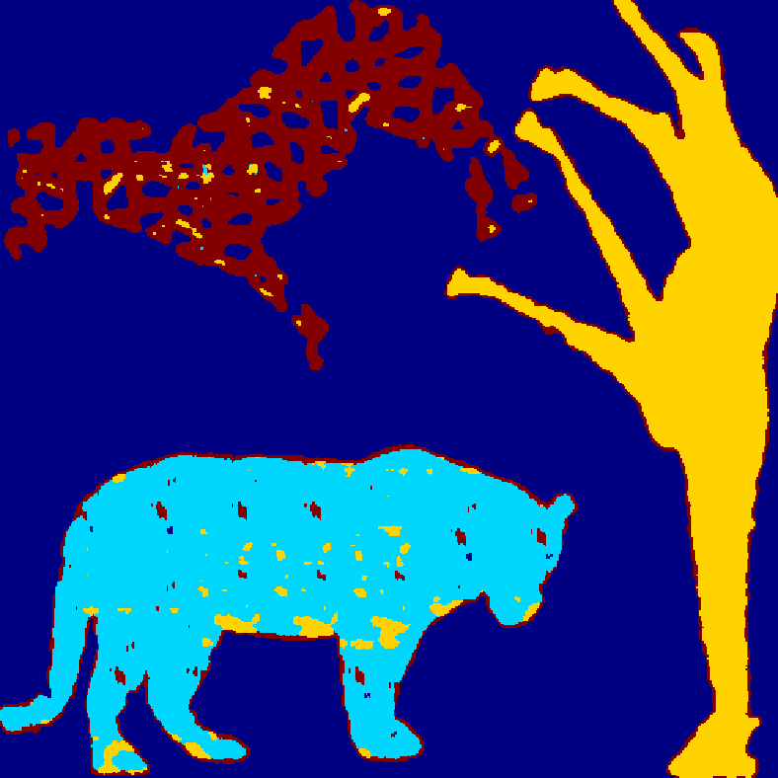

## 

## **Cheetah** has the biggest texture pattern, so window size 25x25 is used to test:

**f5x5\ win_size-25x25\ ABSM-MINMAX.png : a very homogenous classification inside the cheetah.**

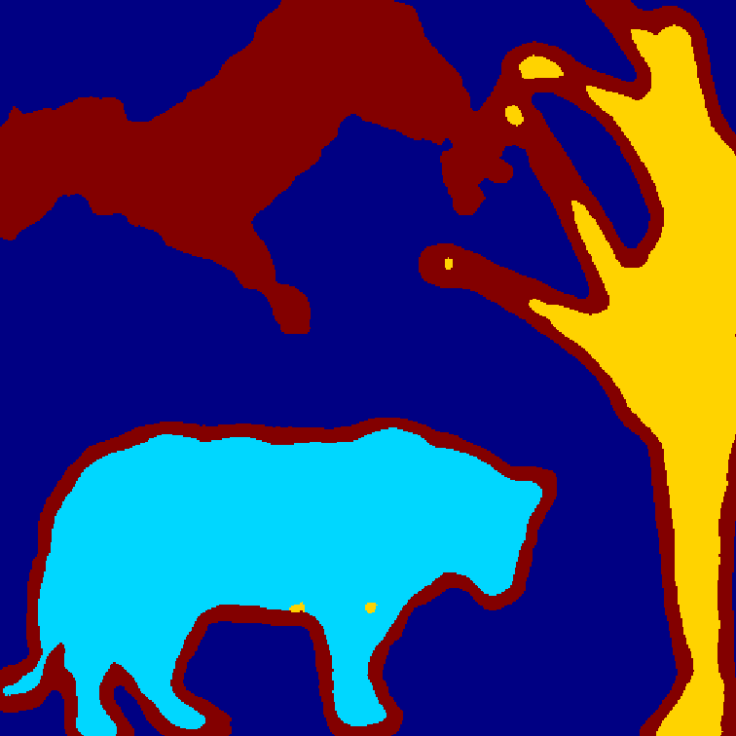

f3x3\ win_size-25x25\ ABSM-MINMAX.png **: this is not as good as f5x5\ win_size-25x25\ ABSM-MINMAX.png.**

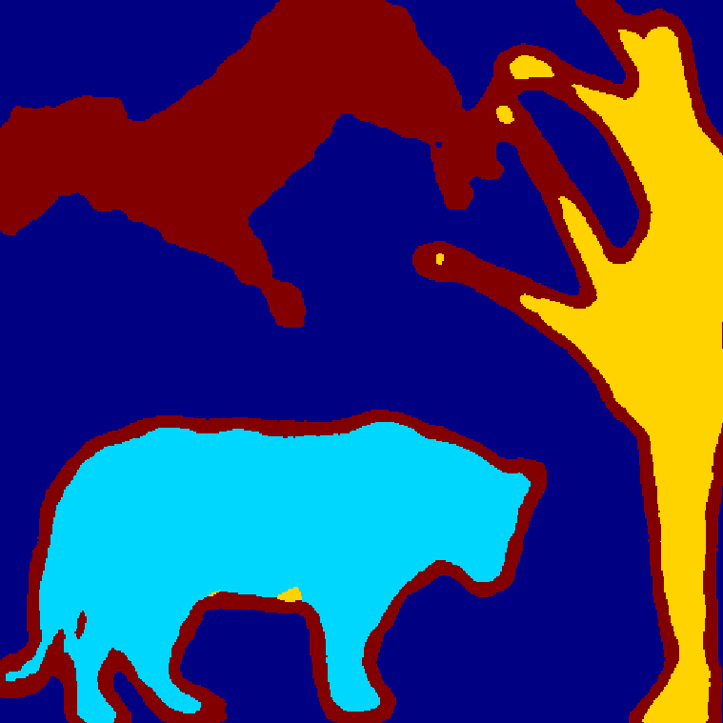

## **Zebra** has a middle size of texture, so window size is 15x15..

**f3x3\ win_size-15x15\ ABSM-MINMAX.png**

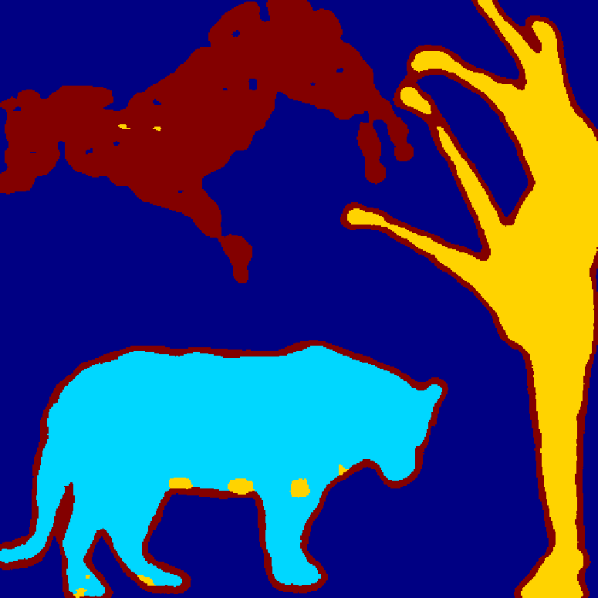

f5x5\ win_size-15x15\ ABSM-MINMAX.png: **it’s not as good as f3x3\ win_size-15x15\ ABSM-MINMAX.png.**

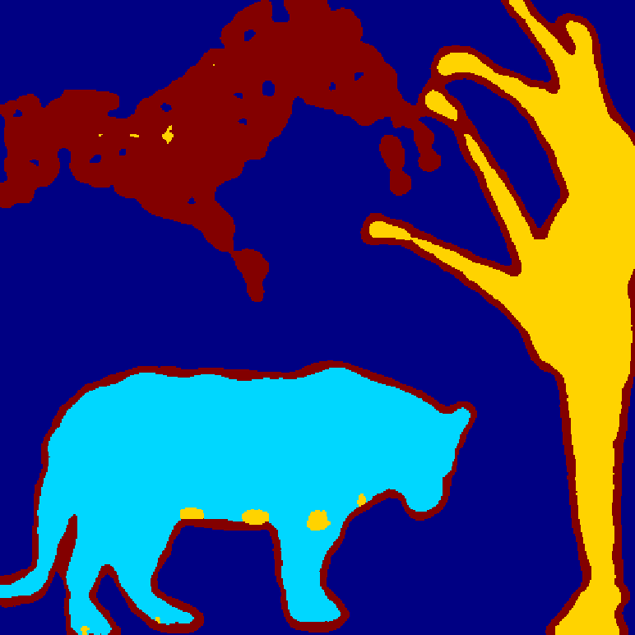

Best of all to distinguish 3 animals simultaneously:

**f5x5\ win_size-15x15\ STDD-MINMAX.png**

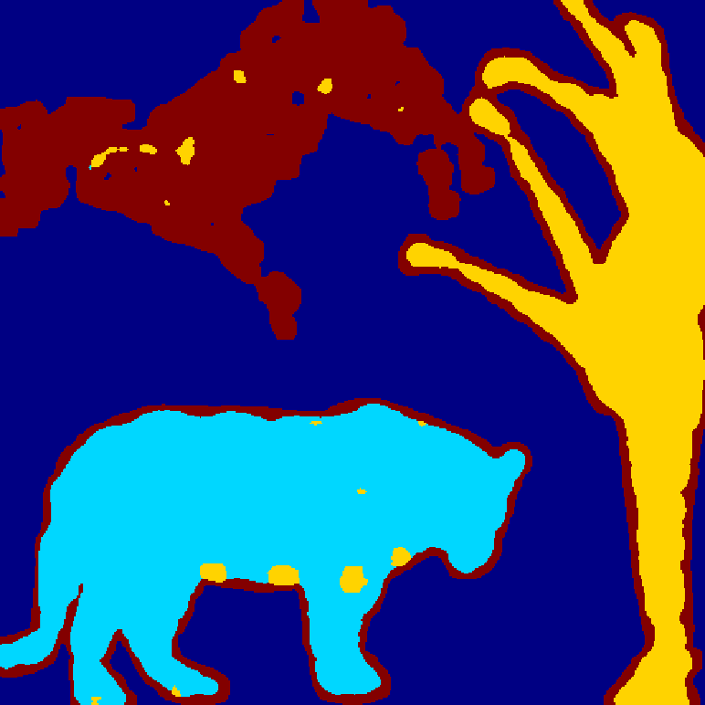

## 

## 

## 

## 

## 

## 

## 

## 

## 

## (c) Based on image L, try to attach the correct texture to each animal as best as you can. Output the result as C.

The correct texture attachment to each animal:

't-3x3 win_size-15x15 ABSM-MINMAX.png' 't-5x5 win_size-15x15 ABSM-MINMAX.png'

't-3x3 win_size-15x15 ENRG-MINMAX.png' 't-5x5 win_size-15x15 ENRG-MINMAX.png'

't-3x3 win_size-15x15 MEAN-MINMAX.png' 't-5x5 win_size-15x15 MEAN-MINMAX.png'

't-3x3 win_size-15x15 STDD-MINMAX.png' 't-5x5 win_size-15x15 STDD-MINMAX.png'

't-3x3 win_size-25x25 ABSM-MINMAX.png' 't-5x5 win_size-25x25 ABSM-MINMAX.png'

't-3x3 win_size-25x25 ENRG-MINMAX.png' 't-5x5 win_size-25x25 ENRG-MINMAX.png'

't-3x3 win_size-25x25 MEAN-MINMAX.png' 't-5x5 win_size-25x25 MEAN-MINMAX.png'

't-3x3 win_size-25x25 STDD-MINMAX.png' 't-5x5 win_size-25x25 STDD-MINMAX.png'

't-3x3 win_size-7x7 ABSM-MINMAX.png' 't-5x5 win_size-7x7 ABSM-MINMAX.png'

't-3x3 win_size-7x7 ENRG-MINMAX.png' 't-5x5 win_size-7x7 ENRG-MINMAX.png'

't-3x3 win_size-7x7 MEAN-MINMAX.png' 't-5x5 win_size-7x7 MEAN-MINMAX.png'

't-3x3 win_size-7x7 STDD-MINMAX.png' 't-5x5 win_size-7x7 STDD-MINMAX.png'

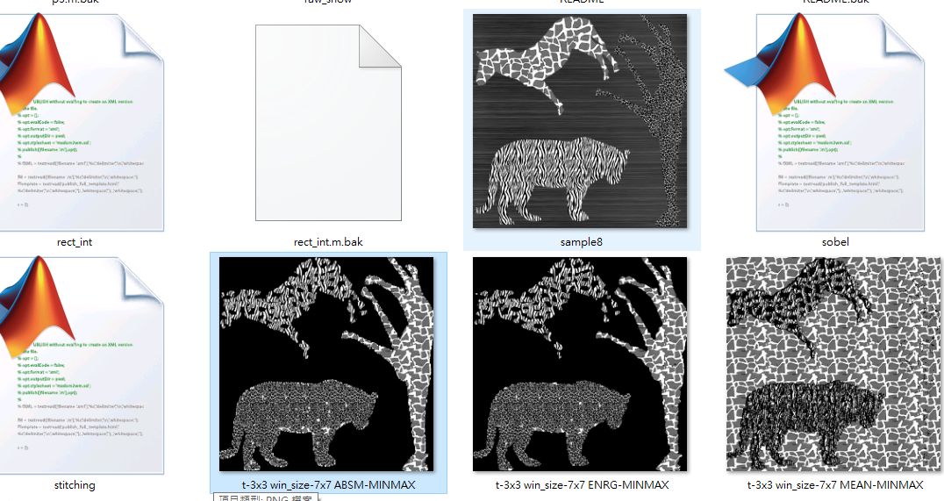

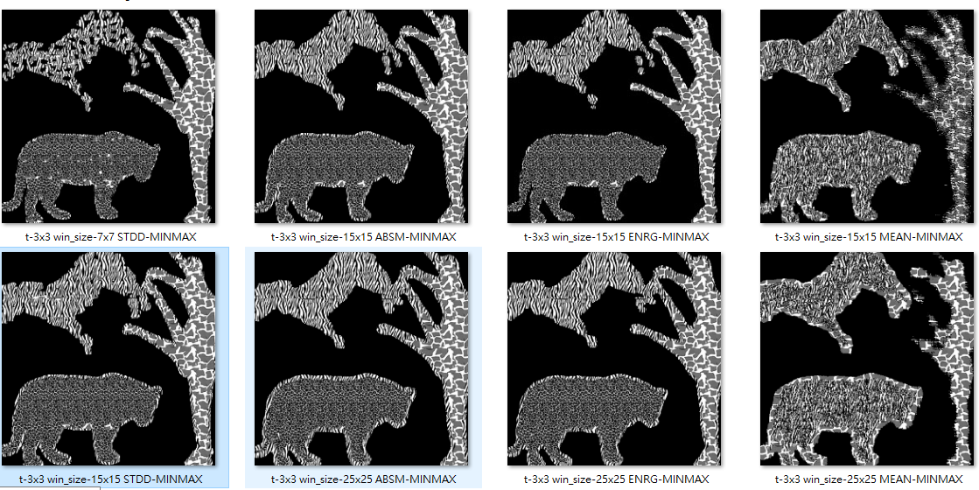

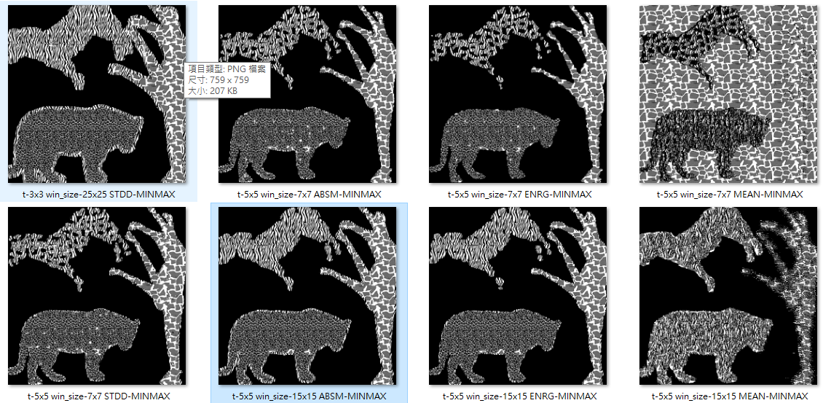

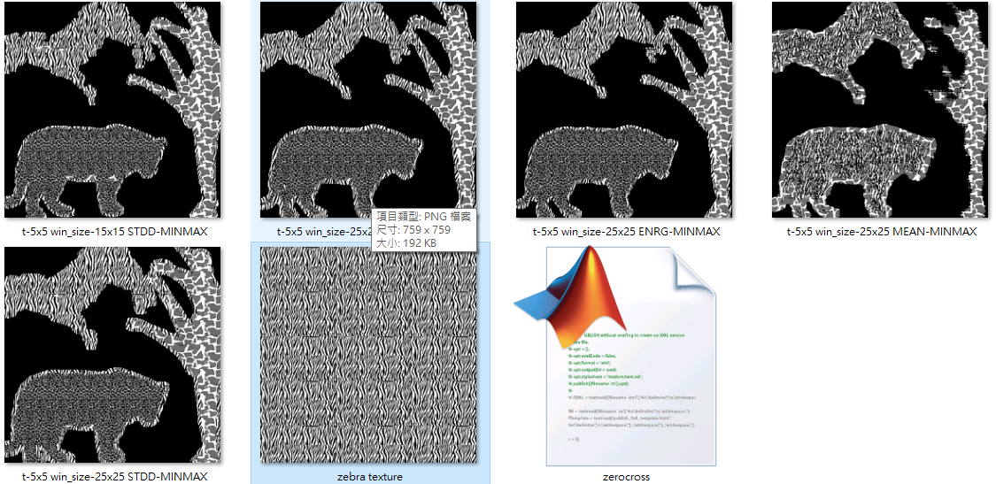

t-3x3 win_size-7x7 ABSM-MINMAX

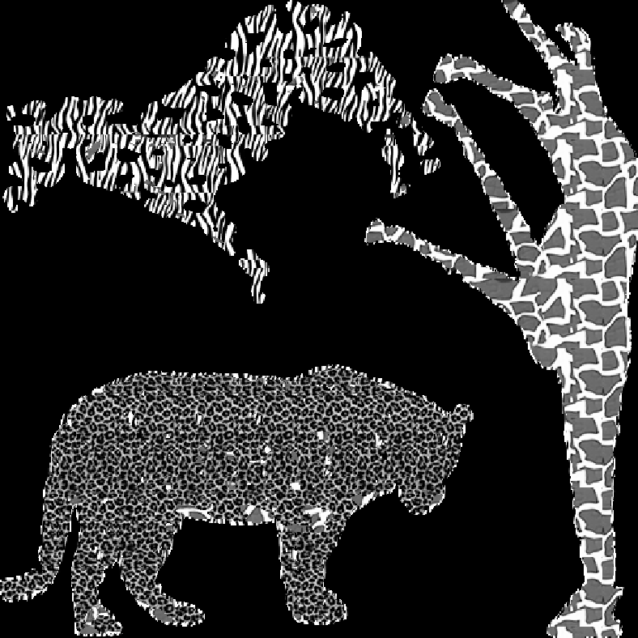

t-5x5 win_size-15x15 ENRG-MINMAX

